Introduction
In this project, the aim is to create an AC to DC converter that can run the DC machine at rated voltage and rotation speed for at least 2 minutes. The inductor current ripple frequency must be greater than 1kHz. The following topologies were considered:
Single-Phase Full Bridge Rectifier + Buck Converter: Simple topology. Uses fewer and readily available components. Requires large capacitor to smoothen the large ripple created by the rectifier stage.
Three-Phase Full Bridge Rectifier + Buck Converter: Comparatively lower voltage ripple while still having a relatively simple topology.
Three-Phase Thyristor Rectifier: Simpler topology, high power capability. High voltage thyristors are less affordable. The circuit requires more complex control to prevent issues and failure.
In the end, we decided to stick to three-phase full bridge rectifier + buck converter to have a smoother ripple. We have chosen our switching frequency to be 50kHz.
Design Specifications
Table 1 shows the design specifications.
Table 1. Design Specifications.
Parameter | Value
Input Voltage | 200 V_{peak} (~141 – 142 V_{rms})
Grid Frequency | 50 Hz
Target Output Voltage | 180 V
Target Load Power | 2000 W
Switching Frequency | 50 kHz

We are also aiming for the following bonuses: Tea Bonus, Closed-Loop Current and/or Voltage Feedback Bonus, Singly Supply Bonus.
We can calculate the required duty cycle by first finding the rectifier output as follows:
$$\begin{aligned}V_{rect}= V_{in}\frac{3\sqrt{6}}{π} ≈330.8 V\#\left(1\right)\end{aligned}$$
We then find the required duty cycle to be:
$$\begin{aligned}D= \frac{V_{out}}{V_{rect}}≈ 0.544\#\left(2\right)\end{aligned}$$
Do note that the DC link capacitor will give a slightly higher average rectified voltage. So, the duty cycle will be slightly lower. In addition, the control loop will dynamically adjust the duty cycle.
For the control loop, an Arduino will be used. The load and the control stage will be isolated by utilizing opto-couplers. A digital current sensor will send the measurements to the Arduino.
(Insert parameter calculation from previous report here if needed)
Component Selection:
(on top of the already given ones in the previous report)
Table 2. Components List.
Arduino Uno
ROE-0512S
ACPL-C870, HCPL-3120
ACS721xLCTR-30A
3x Glass Fuse (25A)
2x TO247 Heatsink
20Ω, 4.7kΩ, 10kΩ, 2MΩ Resistors, 3x 1µF Capacitors

Figure X shows the resulting circuit.
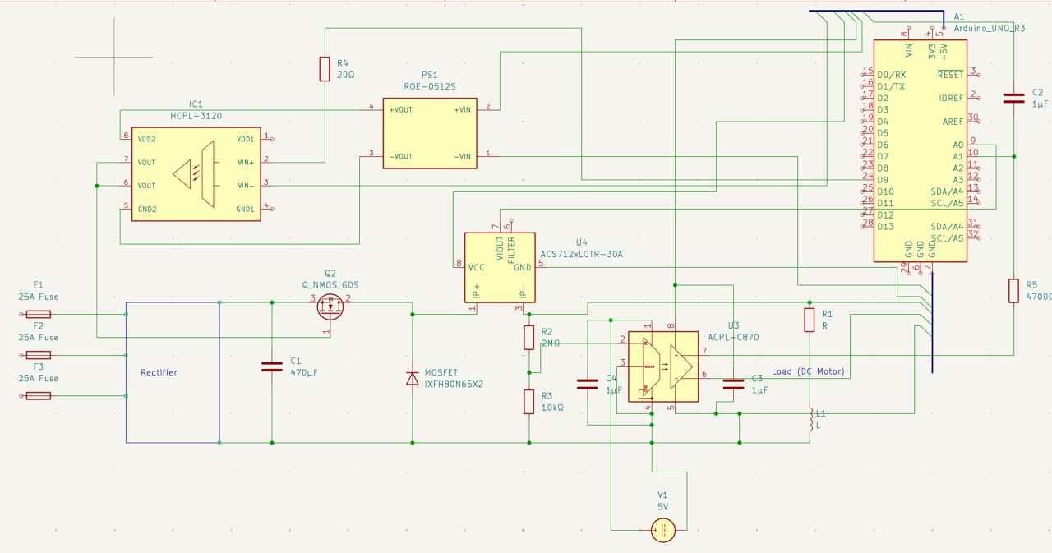
Figure X. The circuit diagram for the project.
Simulation Results
The circuit to be simulated is shown in Figure X +1.
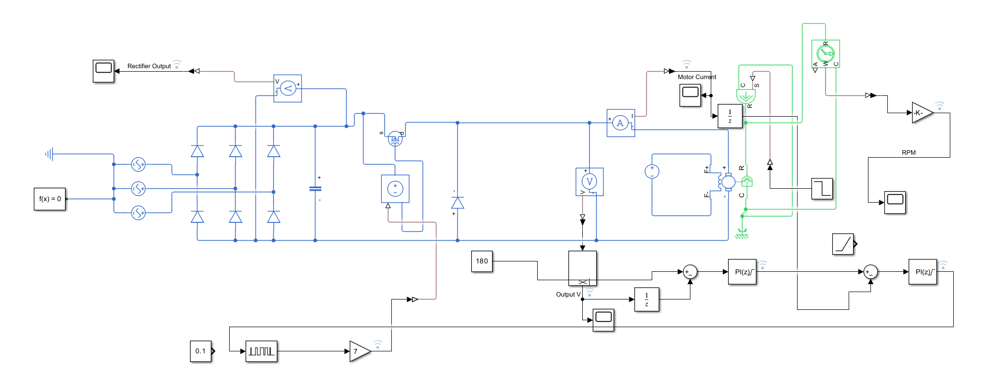
Figure X + 1. The circuit to be simulated.
The resulting waveforms are given in Figures X + 2 (Rectifier Voltage), X + 3 (Motor Voltage), and X + 4 (Motor Current).
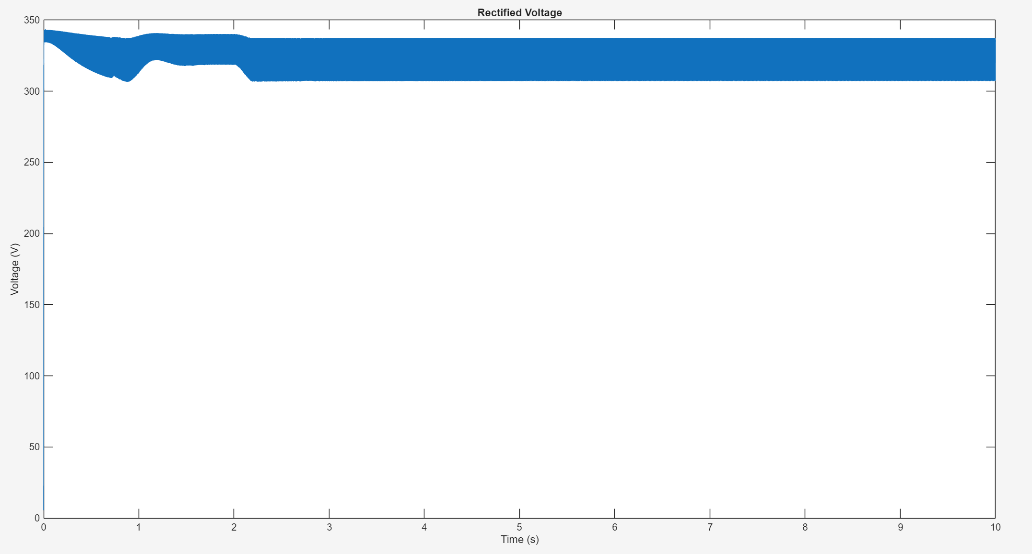
Figure X + 2. Rectifier Voltage.

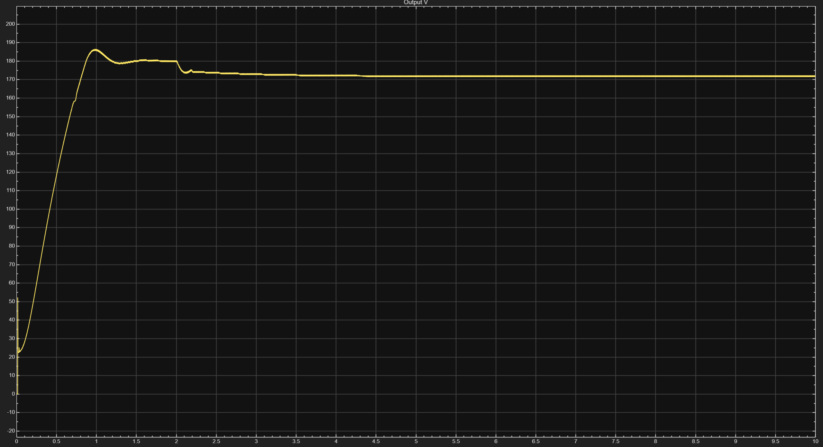
Figure X + 3. Motor Voltage (change to light mode plot later)
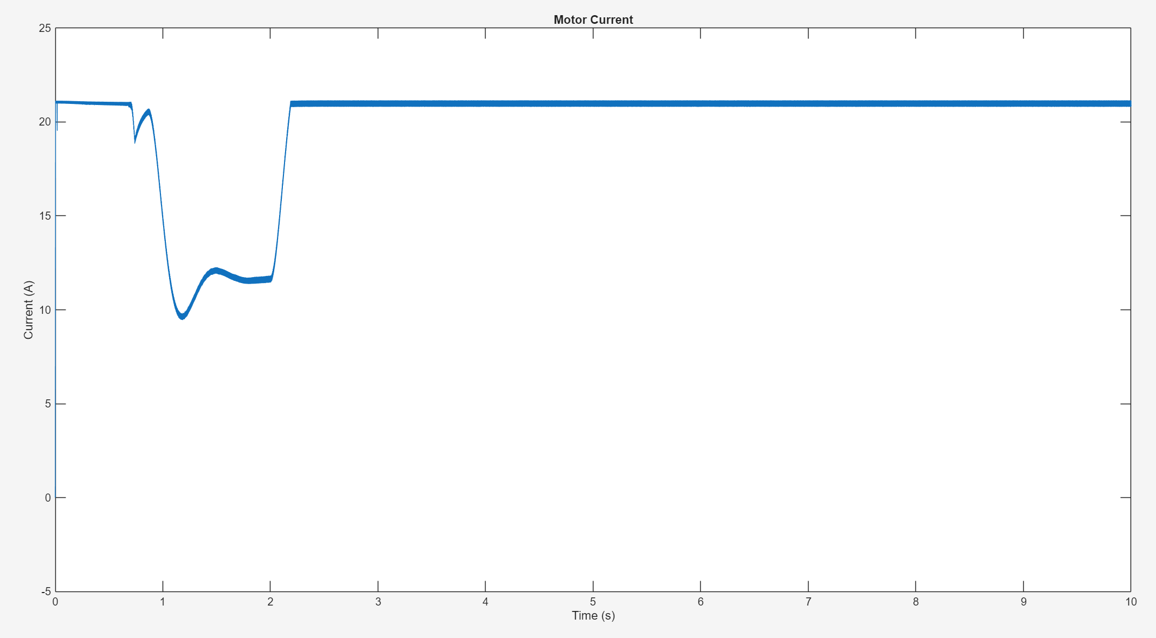
Figure X + 4. Motor Current.

